
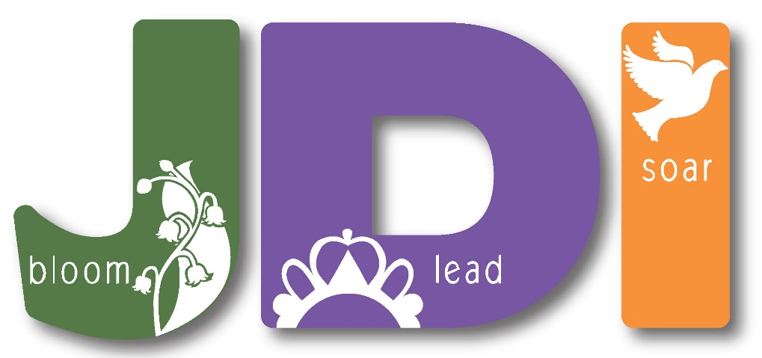

Job’s Daughters International is a leadership organization with girls all over Canada and the United States, as well as Australia, the Philippines, and Brazil. Worldwide, there are over 10,000 girls who belong to Job’s Daughters!


Girls ages 10–19 are able to join our amazing organization, and girls younger than 10 can join as a “Jobie to Bee.” Members of Job’s Daughters gain valuable leadership experience, serve as part of a team, and learn democratic principles as they run their own meetings using parliamentary procedure, decide on activities, and plan service and fundraising events.

Each member is asked to take an office in the group, such as the Recorder, who takes the minutes of our meetings, or a Custodian, who sets up the meeting room. We are girls who love to learn!

We also love to have fun together at activities such as swimming, dances, slumber parties, movie nights, and marching in parades. There are also opportunities to travel to meet and work with girls from around the world!

www.BCJobsDaughters.org
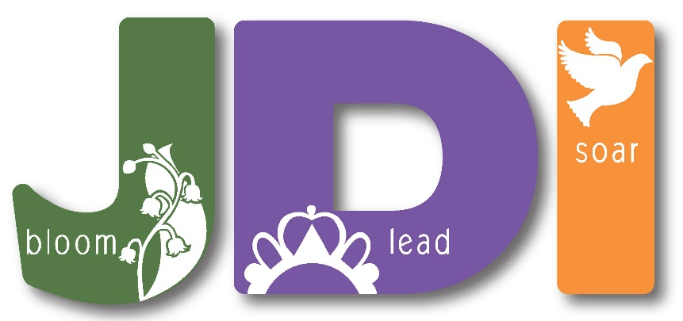


Job’s Daughters International was founded in 1920 by a lady named Mrs. Ethel T. Wead Mick during the height of the Women’s Suffrage movement. Mrs. Mick was a progressive woman and recognized that women’s roles were changing and the chance for women to redefine their place in society was nearing. She wanted the best for her daughters and their friends and her goal was for them to feel important and to be in control of their work.

We get and give each other a lot of support and encouragement. We learn great life skills like, public speaking, leadership, how to plan events, and community service. Jobies, is a fun nickname for Job’s Daughters.


We want you to join with us for fun, friendship, helping others, and the chance to learn more about life! You will be encouraged to be responsible and to participate in the social and family-friendly events and activities we plan. Fairness, honesty, being equal, and respect are the values of Job’s Daughters.

Contact us to find out
about upcoming events!

