BETHEL 22
is selling CHARM BRACELETS!

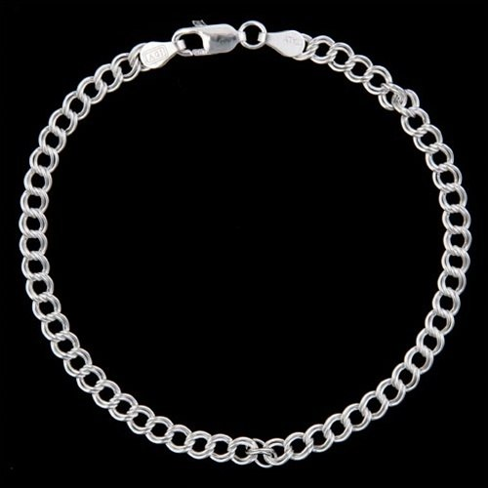

$5.00 each

The new SuperJobie charms along with your station charms will look beautiful on these simple and dainty charm bracelets.
Don’t miss out there is a limited number available!

Contact Mrs. Calhoun at mrs.calhoun@shaw.ca
604-313-4746

