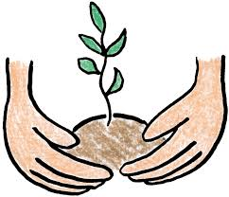
Plant Observation Sheet

Name:

Date Observation Measurement Drawing
Look Like:
Feel like:
Color:
Texture:

Use this chart to record changes in your plant. Write an observation and draw a picture to show changes in your plant from day to day. Be sure to note when the root and shoot first appear. Use a ruler to measure your plant growth.

